Safer Dining and Studying, v 1.0.
C. Stubbs Nov 20, 2020.

Evidence indicates that airborne transmission of COVID-19 currently dominates. This can occur either through droplets (that mostly follow ballistic trajectories) or aerosols (that can remain suspended in the air for extended periods). A physical barrier can suppress droplet transmission, and a combination of filtration and room volume can suppress aerosol transmission. Face masks are effective in source suppression and user protection, for both.

I propose an experiment to ascertain the level of protection that can be achieved from a combined shield + filtration system. This might allow for people to share a table, unmasked, with protection comparable that achieved with masking.

The conceptual design is shown in Figure 1.

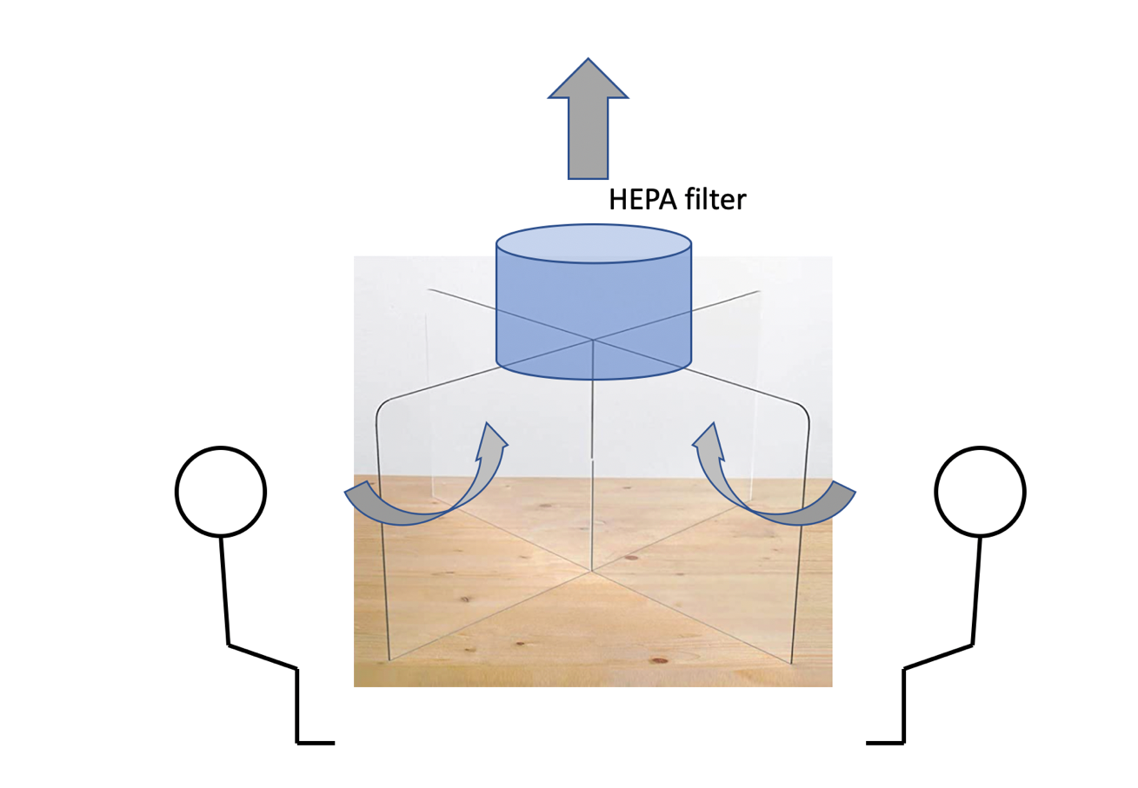

Figure 1. Conceptual design of TableShield. A plexiglass shield protects against droplets while the HEPA filters draws aerosols into a filter.

A prototype comprising the items listed in Table 1 will allow for a quantitative assessment of the transfer function between seats, ideally as a function of particulate size. Acoustic performance will determine whether a microphone + speaker will be needed to facilitate conversation.

 | Amazon link | photo
Shield  $188 | plexiglass shield | 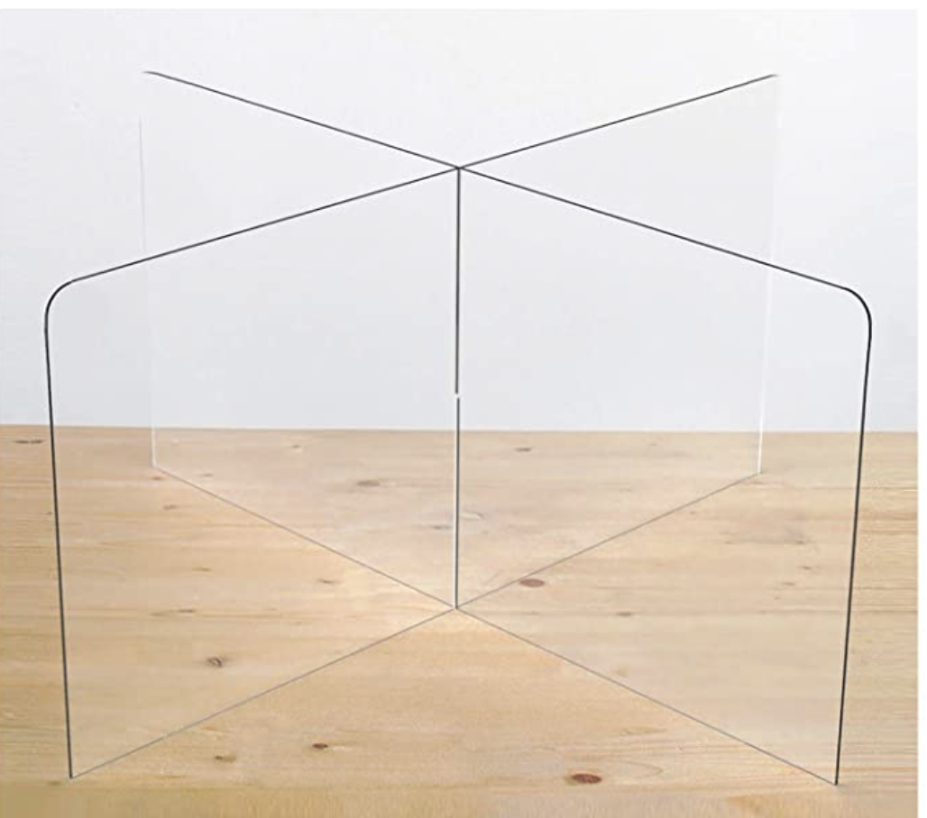
Filter  $68 | HEPA filter | 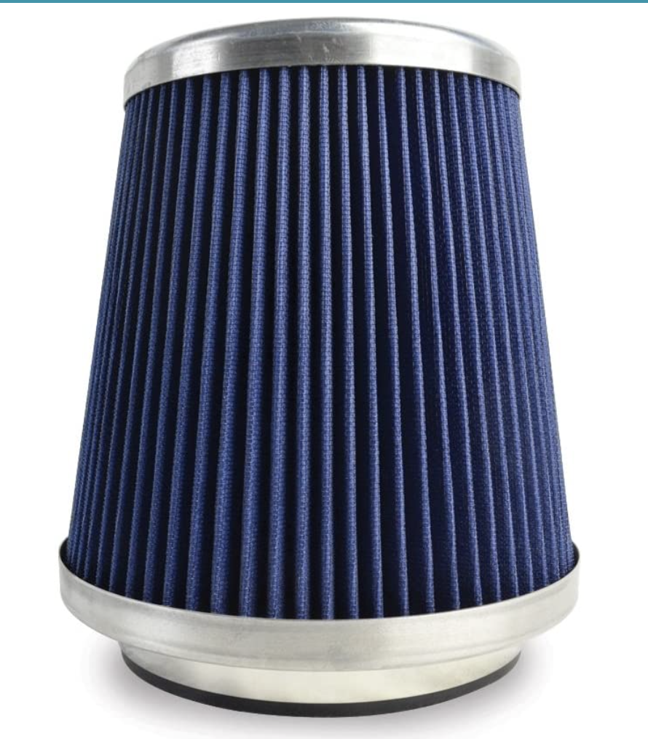
Fan unit  $80 | fan | 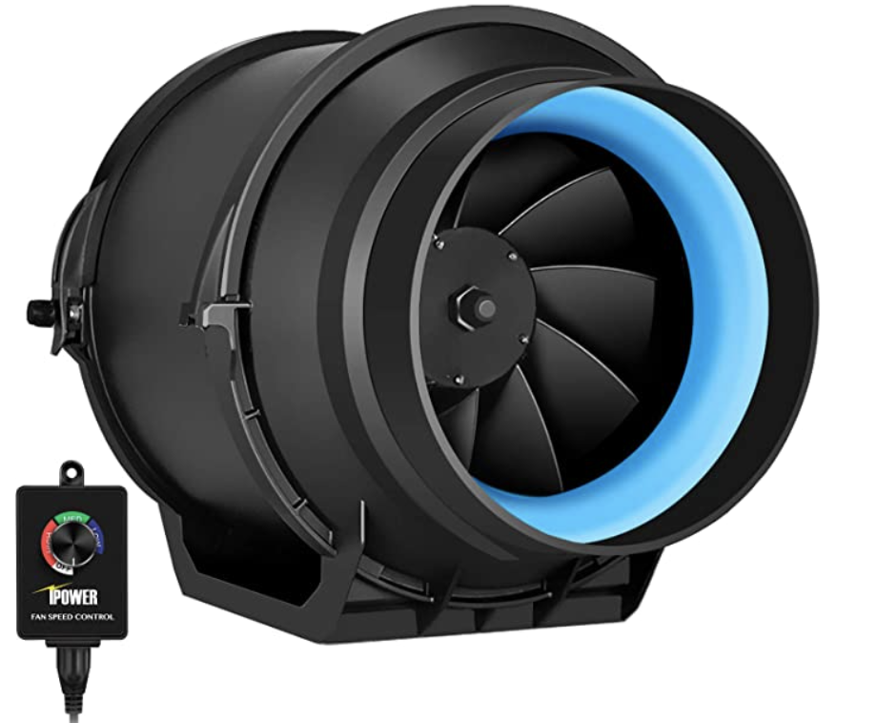

Table 1. Bill of materials.

Measurements to be made include acoustic noise levels, airflow and throughput, filtering efficiency, and the particulate transfer function between locations.

If this works, for around $300 per four-person table we can allow proximate unmasked meals and study sessions.

