Emergency shut down procedure/checklist for ACME
(Emergency contact: Xing Wu 617-9971799; Daniel Ang 413-275-2796; Cole Meisenhelder 267-315-1779)
Name | Cell phone | Note
Xing Wu | 617-9971799
Daniel Ang | 413-275-2796
Cole Meisenhelder | 267-315-1779

Warm up Beam Box I & II
- Stop the buffer gas flow and YAG. On BBII, the Neon flow is stopped by a manual switch. Shut down YAG. On BBI, turn off the house cooling water line for YAG.
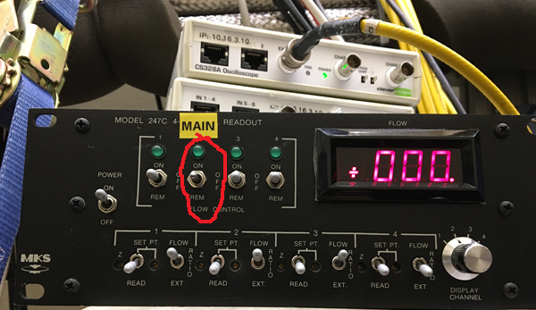
- Close the gate valves between the beam box and the stem and between the stem and the interaction region.
- Turn off the ion sweeper on the Beam Box Ablation and Timing VI. (After doing so, the measured voltage will be around "9V" in BBI. No ion sweeper for BBII at the moment.)
- Switch on the Agilent Triscroll pump located on the west side of the Beam Box I. (for BBII, under the beam box.)
- Spin down both stem turbopumps.
- When the pressure gauge on the beam box roughing line reads less than 10 mTorr, open the gate valve on TOP of the beam box leading to the roughing line.
- Turn the pulse tube compressors off by pressing the black OFF buttons.
- Set the cell heater's "YAG off" voltage to 40 V.
- The pressure will spike to around a few Torr, then start dropping.
- Once the beam box pressure is below 100 mTorr (~40 minutes depending on the amount of Ne ice), set the cell heater voltage to 0 V.
- Close the gate valve between the beam boxes and the Triscroll pumps.
- Switch off the Agilent Triscroll scroll pump.
- Update the deice date on the whiteboard on the door. Allow both beam boxes to come to room temperature under vacuum.
Laser systems
- M² laser
  - Close shutter on Sprout Pump.
  - Turn off Sprout power by pressing the knob, then turning the key to standby mode.
  - Shut off M^2 chiller below the North optics table.
- Diode lasers /Tapered Amplifiers:
  - Turn off diode and TA current controls,
  - Note TEC/temperature settings of all ECDLs and TAs and and leave the TEC/temperature controls ON.
- Iodine clock:
  - Unlock the Iodine line, and turn off TEC control.
  - Turn off chiller.
- ULE cavities:
  - Note the temperature and pressure
  - Leave the TEC on and ion pump on (the ion pumps turn themselves off above pressure threshold).
Water handling
- Switch off YAG house cooling water lines.
- Make sure three compressors are all off (2 for BBII, 1 for BBI). Switch off the 3 Optitemps in G16.
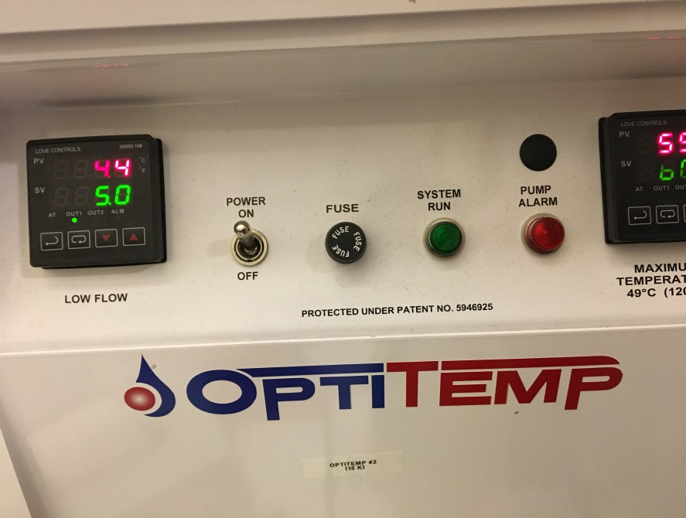

- Turn off house water line to all three Optitemps.
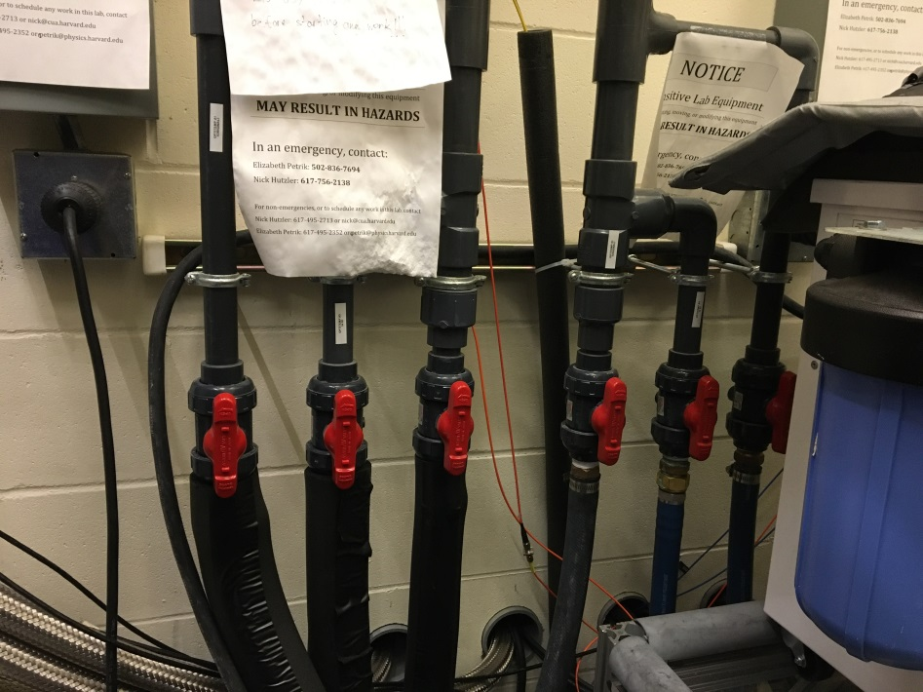
- Turn off all portable water chillers.
Gas handling system
- Close all valves on the beam box panels, and gas cylinders
- Close all valves on the gas handling panels in pump room (g16), and the gas cylinders there.
- Close all valves on the house gas lines.
Computers
- Save all documents
- Save all data and experimental control software on ACME storage drive
- Close any unnecessary tabs.

