COVID Risk Mitigation Procedures for Return to Lab – v10 – revised 26 June
Doyle Group

Table of Contents

- Overview
  - Group spaces and subgroups
  - Principles and approaches
  - Worksheets and schedules
  - Overview of the Physics Space, Group Members, Subgroups, and Procedures

- Lab and Bathroom Density

- Appendix (Forms, Analyses, and Associated Documents)

- FAS/ SEAS PI Lab Re-Occupancy Planning Form - Information on researchers

- Laboratory spaces and subgroups - Details of the physical space and specific procedures for each research room or area
  - Lyman basement
    - Lyman 24C
    - Lyman 24D
    - Lyman 24E
    - Lyman 29
  - LISE ground floor
    - LISE G14
    - LISE G16
    - LISE G16A
    - LISE G18
  - Jefferson first floor
    - Jefferson 160
    - Jefferson 161
    - Jefferson 162
  - 38 Oxford Street
  - Auxiliary preparation spaces
    - Lyman 23C
    - Lyman 24A
    - Lyman 24B
    - Lyman 24F
    - Lyman 27
    - Lyman 31
  - Office spaces
    - Lyman 123 and Lyman 123ABCD
    - Lyman 25
    - Jefferson 263

- Analysis of HVAC in rooms and areas

The principles and the detailed procedures we use are aligned with, or have lower assessed risk than, those presented in:
- Re-entry Plan (from the Dean’s office)
- Introduction and the Level 1B section of Covid Transmission Risk Mitigation Procedures v2
- Assessment and Mitigation of Aerosol Airborne SARS-CoV-2 Transmission

Additional documents
- Example lab space schedule
- Lyman/Jefferson 1 and 2 Bathroom Density Assessment
- LISE B and G Bathroom Density Assessment (planned to be available 15 May)

1 Overview

Our goal is to return to laboratory research while mitigating the risk of transmission of the SARS-CoV-2 virus. The general guideline for the acceptable risk that is used here is that the probability of aerosol transmission to a single healthy person is less than 1% over a six month working period. It is assumed that other risk mitigation methods - those that will be used for preventing close approach of researchers and for preventing surface sharing (described here and in FAS guidelines) - will bring the probability of large droplet and fomite transmission to better than community acceptable levels. As described here these goals are achieved in a straightforward manner due to: 1) the baseline density of researchers per unit lab area, which is inherent in this type of research, 2) the shutting down of a research program, and 3) the de-densification procedures described here, including scheduling.

1.1 Group spaces and subgroups

The Doyle group (“group”) works in the area of quantum science, atomic, molecular, and optical (AMO) physics, and particle physics. Underlying all experimental work is the use of cryostats and lasers to control, cool, and study gas-phase molecules. Experimental work includes almost no chemical “wet lab” work, with the vast majority of work conducted in HEPA-filtered laboratories. Each experiment centers around a major apparatus (“experiment”) that generally contains an optics table with laser sources, optical components, and control electronics; a cryogenic beam source and vacuum system; and an experimental control computer station. An experimental subgroup (“subgroup”) is a group of about ~5-6 people who work on one or two (very closely related) experiments that are housed near each other. Experimental work requires, at any given time, at least one person on site to operate each apparatus. There are required tasks (laser setup, cryogenic maintenance, certain optical adjustments, etc.) that cannot be automated and/or require supervision to ensure the safety and proper maintenance of sensitive laboratory equipment. In this document, we outline procedures to allow return to experimental work while mitigating the transmission of the SARS-CoV-2 virus from presumed infected researchers to a presumed uninfected, susceptible researcher.

The four subgroups are: “ACME” (located in LISE G14, G16, G18, Jefferson 161, 162, and 38 Oxford Street), “CaOH” (located in Lyman 24C), “CaF” (located in Lyman 24E), and “YbOH” (located in Lyman 29). There is no overlap of personnel between subgroups. The ACME and YbOH experiments are further self-contained in the sense that their laboratory space is not contiguous with that of another subgroup. The CaF and CaOH experiments share one HEPA filtered laboratory space, in Lyman 24D, leading to application of both distancing and timing protocols there. All of the physical areas used by researchers are described in detail in Appendix B. A general characteristic of the labs is that they are HEPA filtered and are large enough to accommodate low density occupancy with relative ease. The essential approach to viral transmission mitigation is that all rooms or designated areas within HEPA filtered rooms are single occupancy, meaning that only one person at a time may be in those rooms or areas and a wait time is employed between change of personnel.

1.2 Principles and Approaches
Our plan is guided by several general principles and approaches
- The only permitted work is that which cannot be completed off-site.
- Each room will be single occupancy, except where HEPA filtration and airflow conditions permit otherwise.
  - HEPA-filtered rooms will be split into separate, single occupancy areas. In provided floor plans, separated single occupancy areas are designated (colored green). These plans are in Appendix B.
- A wait time is required when switching a new person into each room or area. The value of the wait time (T_{wait}) is posted and a timer is used. T_{wait} is determined by the HVAC conditions in that area (essentially the air change time, either fresh air for non-HEPA rooms or filtered air for HEPA rooms).
  - Each space will be equipped with a hands-free timer (e.g. foot or proximity). Upon exiting a room, a researcher will activate the timer and no new occupant may enter until the appropriate wait time has elapsed.
- Overlap between researchers from different subgroups is significantly constrained, limited only to necessary shared spaces (e.g., hallways and toilets). Researchers generally will not access rooms that do not contain essential equipment for their experiment.
- Overlap between researchers of the same experimental subgroup will be managed by establishing separate areas and times they will work within a laboratory.

Social distancing (> 2 m) and surgical masks (or respirators or masks with at least as good or better fit and filtration) are required at all times.

1.3 Worksheets and Schedules
Several live documents support our COVID risk mitigation procedures:
- An “interaction worksheet” delineates spaces that may be occupied by each researcher and highlights the conditions by which they may enter other laboratory/office spaces.
Link here: https://docs.google.com/spreadsheets/d/1DgUZlZvMZUTQkQT1IdD6Qf7F86KNcifvDFmakWTQnNI/edit?usp=sharing
- A “lab space schedule” will be maintained with separate tabs for each experimental subgroup’s laboratory space. This will be a “live” Google document to coordinate usage of laboratory space associated with a given experiment.
Link here: https://docs.google.com/spreadsheets/d/1flC4r0tJvlLADxli-6vNASxVZjqsKLBOIwTb94VCBow/edit?usp=sharing
- A “shared space schedule” will be maintained with separate tabs for each shared laboratory space. This will be a “live” Google document to coordinate usage of shared spaces and avoid near-contact between individuals.
Link here: https://docs.google.com/spreadsheets/d/1iozu7HSTSeuHgKLF_WM3G2GFPoXKndOrK0xZTjJ94uI/edit?usp=sharing

An example of such a “lab space schedule” is provided in Appendix G. A bathroom density plan/analysis for the area around the group’s Lyman/Jefferson labs is provided in Appendix H. The bathroom density plan/analysis for the area around the group’s LISE labs is provided in Appendix I.

1.4 Overview of the Physics Space, Group, Subgroups and Procedures

Complete details of physical spaces and procedures for each space are given in Appendix B. We present an overview here.

The group comprises four distinct experimental subgroups (“ACME,” “CaF,” “CaOH,” and “YbOH”), doing experiments in Lyman, Jefferson, 38 Oxford Street, and LISE. Note that these names are often shorthand for more than one experiment and apparatus. Although at first glance this may seem complicated, in our lab, experiments within a subgroup are physically proximal. For example, for our CaF quantum simulation work, both the generation 1 and generation 2 apparatus are in the same HEPA-filtered room. They are distant enough from each other to form separate areas around each apparatus.

A general overview of laboratory spaces and their connections are shown in Appendix B, Fig. 1.1 with color coding to indicate usage criteria. In the figures in Appendix B, green represents an area (always belonging to a single subgroup) intended for a single occupant who may remain for long periods of time, with scheduling determined on a live document and with wait times between occupants; yellow represents a shared area that will be single occupancy with usage scheduled by a live document accessible by the full group; and red indicates areas in which all individuals should spend minimal time (less than a few minutes; hallways are an example). A list of rooms and functions is given in Table 1.

Function | Rooms
Laboratory | Lyman 24C, 24D, 24E, 29  LISE G14, G16, G16A, G18  Jefferson 160, 161, 162  38 Oxford
Auxiliary Prep Space | Lyman 23C, 24A, 24B, 24F, 27, 31
Office | Lyman 25, 123  Jefferson 263
Table. 1 List of laboratories, auxiliary, and office spaces.

The personnel associated with each experiment are distinct - researchers only physically work on a single experiment - and the physical spaces are almost entirely separated along experimental (subgroup) lines. Researchers within each subgroup (ACME, CaF, CaOH, and YbOH), connect spatially for the vast majority of their time only with their subgroup researchers, nearly eliminating contact with other subgroup researchers. This is detailed in the Appendix B.1.

Tables 2 and 3 contain a list of group members that will be doing lab work and the areas each researcher will access, again following single occupancy rules for rooms or areas, as detailed in this document. Appendix B contains graphical representations of laboratory, auxiliary prep, and office spaces.

Lab/Auxiliary Spaces
Subgroup | Names | Lab space access
CaF | Loic Anderegg, Yicheng Bao, Sean Burchesky, Scarlett Yu | Lyman 24E, Lyman 24D*
CaOH | Louis Baum, Christian Hallas, Debayan Mitra, Shivam Raval, Nathaniel Vilas | Lyman 24C, Lyman 24D*
YbOH | Benjamin Augenbraun, Zack Lasner, Alex Frenett, Hiromitsu Sawaoka | Lyman 29
ACME (A) | Daniel Ang | LISE G14, LISE G16, LISE G16A, Jefferson 162
ACME (B) | Cole Meisenhelder | LISE G14
ACME (C) | Xing Wu | Jefferson 160, Jefferson 161
ACME (D) | Zhen Han | Jefferson 160, Jefferson 161, LISE G18
ACME (E) | James Chow | Jefferson 160, Jefferson 161, LISE G14
All subgroups | All group members | Lyman 23C, 27, 31 (Gas cylinder cabinet, electronics room, chemical/fume hood room)
PI | John Doyle | Lyman 24C, Lyman 24D, Lyman 24E, Lyman 27, Lyman 29, Lyman 31, LISE G14, LISE G16, LISE G16A, LISE G18, Jefferson 161, Jefferson 162
Table. 2 List of group members and lab spaces they access for their work. *Lyman 24D is the only area where members of different sub-groups will work, using procedures described in this document.

Office Spaces
Subgroup | Names | Office space access
CaF (A) | Loic Anderegg, Sean Burchesky | Lyman 123A
CaF (B) | Yicheng Bao, Scarlett Yu | Lyman 123D
CaOH | Louis Baum, Christian Hallas, Debayan Mitra, Shivam Raval, Nathaniel Vilas | Lyman 25
YbOH (A) | Benjamin Augenbraun, Zack Lasner | Lyman 123C
YbOH (B) | Alex Frenett, Hiromitsu Sawaoka | Lyman 123B
ACME | Daniel Ang, Cole Meisenhelder, Xing Wu, James Chow, Zhen Han | Jefferson 263
Table. 3 List of group members and office spaces they access for their work. Note that all offices are single occupancy; researchers assigned the same office will use them at different times, with determined wait times between occupancy.

Areas Shared by All Group Members
Auxiliary prep spaces (electronics room, chemical room, gas closet, etc.), and office spaces are considered individually and procedures are outlined. The aim of these procedures is to manage the risk of transmission between the members of different subgroups and the mode is to strictly employ short usage times, require wait times between occupancy, and, as with all rooms and areas, enforce single occupancy. This is described in Appendix B.2.

Office Spaces
Each office room is single occupancy and sharing of a room will be done only within an experimental subgroup (PIS) and requires wait times between occupancy. Desks are not shared; they will be assigned and clearly labeled for each individual. This is described in Appendix B.3.

Conference Room
The group conference room, containing a large meeting meeting space and kitchen area, is located in Lyman 123A. Due to the restrictions we are imposing to limit Cov2 transmission risk, the kitchen area will not be used. The conference room will be used as a single-occupancy office space, so it is described in Appendix B.3.

2 Lab and Bathroom density
The group usually would have 25+ researchers working (simultaneously) in the labs during the summer. By shutting down one experiment completely, and implementing the procedures outlined in this document, there would be maximum of 9 people working at any given time, all in single occupancy rooms or separated HEPA filtered areas. This is close to the 25% indicated in the Science Re-occupancy Planning document, while achieving low probability of aerosol viral transmission over a six month period. Determination of the number of people using bathrooms indicates a density about 20% of normal for Lyman/Jefferson 1st and 2nd floors, as described in Appendix H. The bathroom usage density for LISE basement and ground floor is described in Appendix I.

3 Appendix (Forms, Analyses, and Associated Documents)

The following pages contain the Science Re-Occupancy Forms, a detailed analysis of physical spaces and air flow, and several associated documents that describe modes of analysis and development of guidelines.

Appendix B: Laboratory Spaces, Characteristics, and Personnel
This section describes the laboratory spaces used by the group. For each room, it includes a description of the space (with annotated floor plan), a list of the individuals with access, the work to be performed in that space, and the procedures used to minimize risk of transmission within the space. Analysis of airflow in rooms that permit multiple occupancy (HEPA filtered) are described in Appendix C. In the drawings below, thick solid lines indicate walls, whereas thick dashed lines indicate separate single occupancy areas within rooms. A summary list of spaces is given in table 1.1.
Room | Primary use | Air flow [CFM]  (Fresh airlow [CFM]) | HEPA? | Capacity | Personnel with access
Lyman 24C | CaOH control | 1100  (500) | Yes | 2 | CaOH only: Louis Baum, Christian Hallas, Debayan Mitra, Shivam Raval, Nathaniel Vilas
Lyman 24D | CaOH/CaF optics | 4200  (300) | Yes | 2 (see section 1b) | *see details below for procedures - Loic Anderegg, Yicheng Bao, Louis Baum, Sean Burchesky, Christian Hallas, Debayan Mitra, Shivam Raval, Nathaniel Vilas, Scarlett Yu
Lyman 24E (High bay) | CaF control | 2000  (1400) | Yes | 3 | CaF only: Sean Burchesky, Yicheng Bao, Scarlett Yu, Loic Anderegg
Lyman 29 | YbOH lab | 3000  (300) | Yes | 2 | YbOH only: Ben Augenbraun, Alex Frenett, Zack Lasner, and Hiromitsu Sawaoka
LISE G14 | ACME lab | 2500  (400) | Yes | 2 | ACME only: Cole Meisenhelder**, Xing Wu, Daniel Ang, James Chow**, Zhen Han
LISE G16 | ACME lab | 720  (1144) | Yes | 1 | ACME only: Cole Meisenhelder, Xing Wu, Daniel Ang**
LISE G16A | ACME lab | NA  (600) | No | 1 | ACME only: Cole Meisenhelder, Xing Wu, Daniel Ang**
LISE G18 | ACME lab | 300  (200) | Yes | 1 | ACME only: Cole Meisenhelder, Xing Wu, Daniel Ang, James Chow, Zhen Han**
Jefferson 160 | ACME lab | 1050  (290) | No | 1 | ACME only: Cole Meisenhelder, Xing Wu**, Daniel Ang, James Chow, Zhen Han
Jefferson 161 | ACME lab | 340  (190) | No | 1 | ACME only: Cole Meisenhelder, Xing Wu**, Daniel Ang, James Chow, Zhen Han
Jefferson 162 | ACME lab | 1052  (190) | No | 1 | ACME only: Cole Meisenhelder, Xing Wu, Daniel Ang**, James Chow, Zhen Han
Table. 1.1 Laboratory spaces and relevant airflow properties.
*Overlap to be minimized by dividing Lyman 24D into separate work areas by subgroup, designed to mitigate airflow between subgroups. See section 1.b below.
** Primary room occupant; others are allowed to access only with prior notice as described in Appendix B.

General Laboratory Risk Mitigation Procedures
The in-lab procedures that will be used to minimize risk of disease transmission are those drawn from Appendices D, E and F and additional FAS guidance documents. A very brief summary is given here. Each worker will procure a personal computer keyboard/mouse set to eliminate shared surfaces at the computer control stations. Desk spaces will be wiped down periodically. Each worker will have an individual set of commonly used tools (e.g. ball drivers). Gloves will be worn and changed at regular intervals using the ‘double glove’ method.. Lab entrance and exit will use a hands free method.

1. Lyman Basement
The basement of Lyman has the following types of spaces, Doyle Group Labs (outlined in solid lines), Doyle Group auxiliary spaces (“gas cabinet” 23C and mechanical room 24F), the Student Machine Shop (parts are shown in diagram as 32A, 34), and Hau Group Lab (23A, 23, 23B).
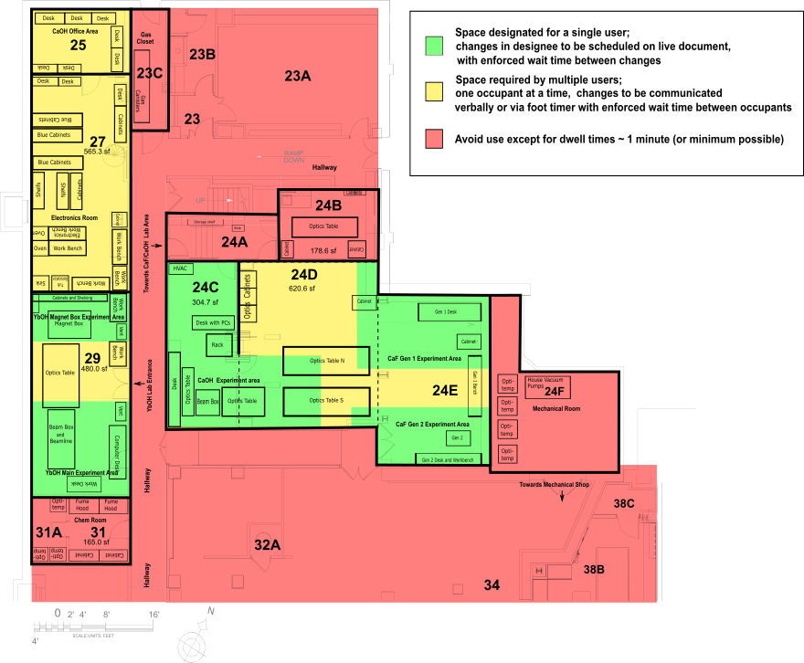
Figure 1.1 Lyman Basement floor plan. Walls that demarcate group spaces are outlined in bold lines.

Brief explanation: Lyman 24C has been divided into two green areas, "CaOH Experiment Area A" and "CaOH Experiment Area B," each of which is allowed single occupancy. This change reflects increased airflow in the space due to the commissioning of a new HVAC system for Lyman 24C and to the introduction of a new ULPA filtration unit placed between the two experimental regions. This sufficiently separates airflow to enable double occupancy of 24C.

Lyman 24B has been changed from a 'red' to a 'yellow' region, which reflects the commissioning of a new HVAC system providing 1100 CFM of HEPA filtered airflow to the space. The room is now rated for single occupancy, with personnel changes requiring a wait time of 5 minutes.

1.a. Lyman 24C
Physical Overview
Lyman 24C houses the apparatus and control region for the CaOH experiment. See Fig. 1.a.1 for a schematic of the room, including regions indicating where researchers may spend time. The room is approximately 305 sq. ft. in area and currently has 500 CFM of fresh air and 600 CFM of ULPA filtration from a fan filter unit, corresponding to >15 air changes per hour. A HEPA filter services the air in this room. The primary entrance to this space is through a door from Lyman 24A. Lyman 24C also connects directly to Lyman 24D.

Experimental Work
Work will focus on returning the main CaOH apparatus to operating condition. This will entail returning parts to high vacuum conditions and restarting cryogenic systems. Extensive optics work will additionally be required to restore daily operation of the experiment. Running an experiment entails steering optics, adjusting lasers, etc.

Procedures to minimize risk of transmission
See “General Laboratory Mitigation Procedures” described near the top of this appendix. Access to Lyman 24C will be solely through Lyman 24A.

Personnel with access
Five members of the group (Louis Baum, Christian Hallas, Debayan Mitra, Shivam Raval, Nathaniel Vilas) will be allowed to work in Lyman 24C. Other lab members are not permitted to enter, except with prior notice, and with dwell times < 1 minute.

Schedule to minimize overlap of personnel
Two members of the CaOH subgroup will be allowed access to Lyman 24C at any given time; one in “CaOH Experiment Area A” and one in “CaOH Experiment Area B,” as designated in Fig. 1.a.1. These experiment spaces are divided by an ULPA filtration unit separating the airflow in the two regions.
Any work that can be conducted off-campus (e.g., data analysis, software development, hardware design, etc.), will be. The preferred schedule will be to have a weekly rotation such that two people work in Lyman 24C for five days, with a different subgroup member resuming work after the weekend. However, the air circulation in this space is sufficient to allow daily alternation of personnel. Level 1B procedures will be followed to mitigate surface transmission. A live scheduling document will be used.
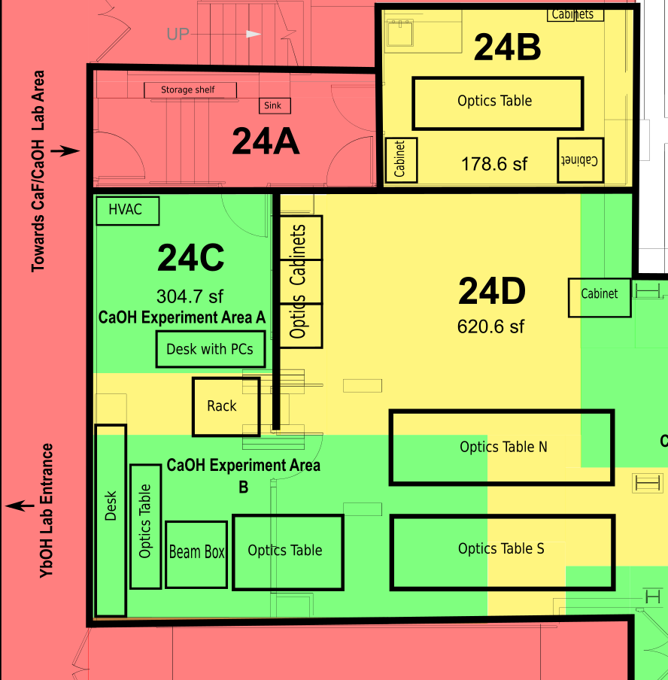
Fig. 1.a.1 Overview of CaOH experiment areas. Note that Lyman 24A will be used as an entryway to Lyman 24C by the CaOH experiment subgroup members only. Thick solid lines indicate walls and thick dashed lines indicate separate single occupancy areas within rooms.

Preparation of room for resumption of work
Prior to work resumption, tools (e.g., ball drivers, wrenches, etc.) and optics (mirrors, lens, post assemblies, etc.) will be retrieved from cabinets in Lyman 24B and Lyman 24D for primary use. Touch free entrance and exit from Lyman 24C will be ensured by placing one-time use wax paper sheets and trash receptacles on either side of the door to Lyman 24A, as well as the door between Lyman 24A and the hallway. Alternatively, touch-free handles may be installed. Additionally, a waste bin, glove dispenser, and tissue/wipe station will be placed in Lyman 24C. Signage will be installed indicating that areas should not be entered without first conferring with a member of the CaOH subgroup. Floor demarcations between Lyman 24C and 24D will be clearly marked.

1.b. Lyman 24D
Physical Overview
Lyman 24D houses two optics tables (“table N” (5x16 ft.) and “table S” (4x16 ft.)) with lasers and beam delivery systems for the CaOH and CaF experiments, as well as storage cabinets containing optics hardware and other tools. See Figs. 1.b.1 for a schematic of the room, including regions indicating where researchers may spend time. The room is approximately 620 sq. ft. in area and features 4200 CFM total airflow (300 CFM fresh air), equivalent to 30 air changes per hour (>2 fresh air changes per hour). A HEPA filter services the air in this room. The primary means of access is via Lyman 24E and Lyman 24C, both of which connect directly to the space with no doorways. The door between Lyman 24D and Lyman 24A will remain closed and may only be used to allow access to Lyman 24B by authorized personnel.

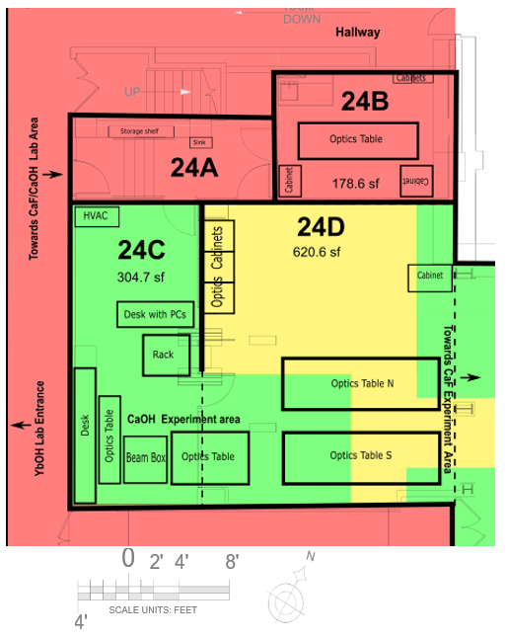
Figure 1.b.1 Designated areas for single-subgroup (green), and multiple-user (yellow) operation in Lyman 24D.

Work to be performed
Work will focus on returning the main CaF and CaOH lasers and laser-locking systems to operating condition. Optics work will additionally be required to restore daily operation of the experiment. Running an experiment entails steering optics, adjusting lasers, etc.

Procedures to minimize risk of transmission
See “General Laboratory Mitigation Procedures” described near the top of this appendix. Entrance and exit will be only via Lyman 24E and Lyman 24C for the CaF and CaOH subgroups, respectively. The doorway between Lyman 24D and Lyman 24A will not be used, except for the rare circumstance in which access to Lyman 24B is required by authorized CaF personnel. In this case, researchers will follow hands free procedures described below. Overlap between personnel will be as described below.

Personnel with access
Nine members of the group (Loic Anderegg, Yicheng Bao, Louis Baum, Sean Burchesky, Christian Hallas, Debayan Mitra, Shivam Raval, Nathaniel Vilas, Scarlett Yu) will be allowed to work in Lyman 24D (All users of this area also have access to either Lyman 24C or Lyman 24E.) Other lab members would enter only with prior notice and dwell times < 1 minute.

Schedule to minimize overlap of personnel
The space will be divided into several work areas belonging to individual subgroups (CaF “Gen 1”, CaF “Gen 2”, CaOH), chosen to allow access to critical pieces of equipment while avoiding airborne transmission between subgroups (see green regions of Fig. 1.b.1). All portions of Lyman 24D not designated for individual subgroups are considered “multiple-user,” (in yellow) and will require a wait time of 5 minutes, corresponding to ~2 air changes, between subsequent occupants (yellow regions of Fig. 1.b.1). Entry to the “multiple-user” regions of Lyman 24D for short times of <1 minute (for instance, to retrieve materials from a cabinet or to re-lock a laser) is permitted without being treated as “room occupancy”. Such excursions will be minimized. Communication regarding the last time of occupancy may be relayed verbally to all other users of Lyman 24C and Lyman 24E or by a hands-free timer. Prior coordination of daily startup times will be performed electronically. Any work that can be conducted off-campus (e.g. data analysis, software development, hardware design, etc.), or in designated areas of Lyman 24C and/or Lyman 24E, will be.

Preparation of room for resumption of work
Touch free entrance and exit from Lyman 24D is guaranteed because there are no doorways separating it from Lyman 24C or Lyman 24E. One-time use wax paper sheets and trash receptacles will be placed on either side of the door between Lyman 24D and Lyman 24A, though use of this doorway will be avoided whenever possible, and is strictly limited to authorized occupants of Lyman 24E who require access to Lyman 24B storage. Floor demarcations will be placed to clearly mark boundaries between designated subgroup work areas and multiple-user spaces.

1.c. Lyman 24E

Short description:
In the current build phase of the Gen 2 apparatus, one student is nearly continuously working on side projects that can be completed outside of the laboratory space (machine shop). Additionally, the gen 2 area can accommodate two researchers working over the optical table due to the ~8 feet separation and airflow. This will greatly improve productivity

For Gen 1, the control station can accommodate two researchers with six feet of separation. An overhead HEPA filter draws air away to ensure aerosol isolation between researchers. Apparatus trouble shooting will benefit greatly from having two researchers present at the same time.

Physical Overview
Lyman 24E (colloquially known as the “high bay”) houses the main apparatus and control region for the CaF “Gen 1” and “Gen 2” experiments. See Fig. 1.c.1 for a schematic of the room, including regions indicating where each researcher may spend time. The room is approximately 27 ft. x 16 ft. x 26 ft. and features 2000 CFM total airflow (1400 CFM fresh air), equivalent to >10 air changes per hour (>7 fresh air changes per hour). A HEPA filter services the air in this room. The primary entrance to this space is through a door from the hallway adjacent to Lyman 34 (the “SEAS student machine shop”). Lyman 24E also connects directly to Lyman 24D.
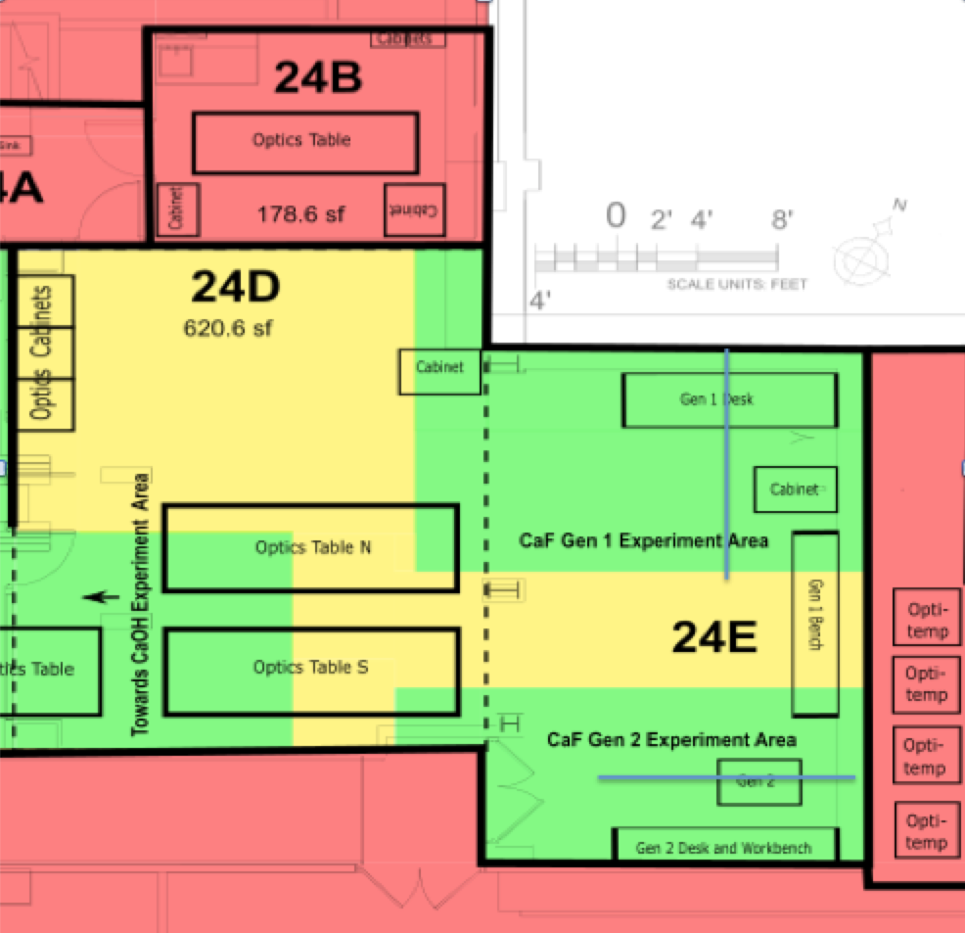

Fig. 1.c.1 Overview of CaF experimental areas. Lines indicate regions where two researchers can work together on an optical table or data taking station.

Work to be Performed
Construction on the CaF “Gen 2” apparatus will continue on the South side of the room while on the North side, data will be collected for an ongoing experiment in the “Gen 1” apparatus.

Procedures to minimize risk of transmission
See “General Laboratory Mitigation Procedures” described near the top of this appendix. Entrance and exit will be only through the door between Lyman 24E and the hallway (not via Lyman 24D).

Personnel with access
Four members of the group (Loic Anderegg, Yicheng Bao, Sean Burchesky, Scarlett Yu) work in Lyman 24E. Other lab members would enter only with prior notice and dwell times < 1 minute.

Schedule to minimize overlap of personnel
At most four authorized personnel will be allowed access to Lyman 24E at any given time, with a maximum of two operating in the “Gen 1” area and the two other in the “Gen 2” area. The researchers will work without shifts. On the “Gen 2” side, at least one researcher is often doing fabrication work outside of the lab (Machine shop, water jet at 38 Oxford, Electronics room). Researchers working on opposite sides of the “Gen 2” optics table are separated by about 8 feet and have adequate airflow to allow two researchers to work while satisfying the separation guidelines. In the “Gen 1” area, space on the control desk labeled “Gen 1 desk” in figure 1.c.1 is increased to allow 6 feet of separation between researchers. The overhead HEPA filtration system draws air up and away, allowing for a safe environment for two researchers to work. Any work that can be conducted off-campus (e.g., software development, hardware design, etc.) will be.

Preparation of room for resumption of work
Prior to work resumption, tools (e.g., ball drivers, wrenches, power meters, fiber coupling pens, etc.) and optics (mirrors, lens, post assemblies, etc.) will be retrieved from cabinets in Lyman 24B and Lyman 24D for primary use. Touch free entrance and exit from Lyman 24E will be ensured . Additionally PPE dispensers and disposal sites will be placed near the Lyman 24E entrance. Floor demarcations will be clearly marked to indicate boundaries between CaF “Gen 1” and “Gen 2” experiments, as well as between 24E and 24D optics table space. Waiting areas for lasers requiring occasional access throughout the day will also be indicated with floor demarcations. Storage areas will be labeled for individual computer keyboards/mice.

1.d. Lyman 29
Lyman 29
Lyman 29 houses the YbOH experiment. See Fig. 1.d.1 for a schematic of the room, including regions indicating where each researcher may spend time. The room is approximately 30 ft x 15 ft and features 3000 CFM total airflow (300 CFM fresh air), equivalent to >30 air changes per hour (>3 fresh air changes per hour). A HEPA filter services the air in this room. The YbOH experiment comprises two primary experimental areas located on opposite ends of the room: the “main beam source” (South side) and the “magnet box” (North side). The North side of the room also contains cabinets and shelving stocked with optics and tools. A 5 ft x 16 ft optics table spans the central portion of the room. Some mechanical equipment (water chillers and pulse tube compressors) is located in the back of Lyman 31, although these are accessed infrequently (~1 per week) and provide sufficient air changes between different personnel entering the room.

Work to be performed
Initial work will focus on returning the cryogenic and laser systems to full working condition. Work on the North side will be focused on returning the magnet box and associated cryogenic systems to working conditions. Work on the South side of the room will bring a similar cryogenic system back online and establish a high vacuum in an associated vacuum chamber. Extensive laser work is required to return the many lasers to operation. Once lasers and systems are operational, experiments can be run in single occupancy mode.

Procedures to minimize risk of transmission
See “General Laboratory Mitigation Procedures” described near the top of this appendix.

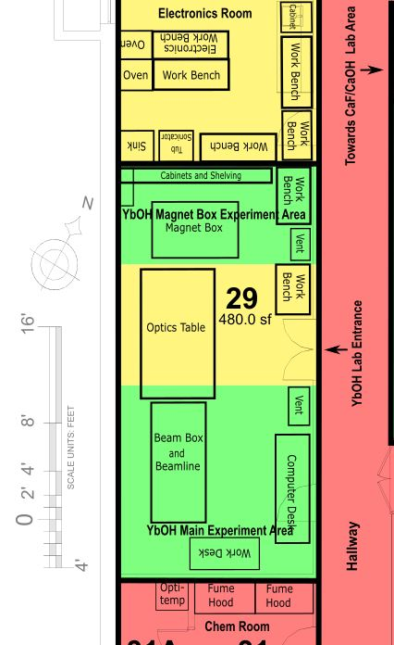
Fig 1.d.1 YbOH area indicating two separate single occupancy work zones in green. The green zones represent allowed working areas. Yellow zones are also single occupancy but may be accessed by either worker with sufficient wait time and minimum dwell time.

Personnel with access
Four members of the group (Ben Augenbraun, Alex Frenett, Zack Lasner, and Hiromitsu Sawaoka) will work in Lyman 29. Other lab members could enter only with prior notice and dwell times ~1 minute.

Schedule to minimize overlap of personnel
There will be a live Google doc used for scheduling, as described above. Any work that can be conducted off-campus (e.g., data analysis, software development, hardware design, etc.) will be. At most two people will be permitted in Lyman 29 at any given time, with one person on the North side and one on the South side. A live scheduling document will be used.

Preparation of room for resumption of work
Prior to work resumption, tools (e.g., ball drivers, wrenches, etc.) and optics (mirrors, lens, post assemblies, etc.) will be distributed between the two portions of the room. Optical components typically retrieved from the cabinets in Lyman 24 will be moved in bulk into Lyman 29 in order to eliminate overlap with the CaF and CaOH experiments. Touch free entrance and exit from Lyman 29 will be ensured by placing one-time use wax paper sheets and trash receptacles on either side of the door. Space 1 meter to either side of the room’s centerline will be clearly demarcated with tape in order to ensure >2 m separation between workers at all times.

2. LISE Ground Floor

The ACME subgroup uses LISE G14, G16, G16A, and G18. LISE G16 is a mechanical/ maintenance space.

2.a. LISE G14
Physical Overview
LISE G14 houses several components of the main ACME apparatus, including two optics tables (North and South) with various lasers and other optics equipment, the “Beam Box I” apparatus, the ACME II interaction region, and two experimental control stations with computers (North and South). The room is approximately 508 sq. ft. in area and has a HEPA filtered HVAC system with >13 air changes per hour and >2 fresh air changes per hour. The primary entrance to this space is through a double door from the hallway. There is also a single door connecting to G16. Fig. 2.a.1 shows LISE G14, G16, G16A, and G18.

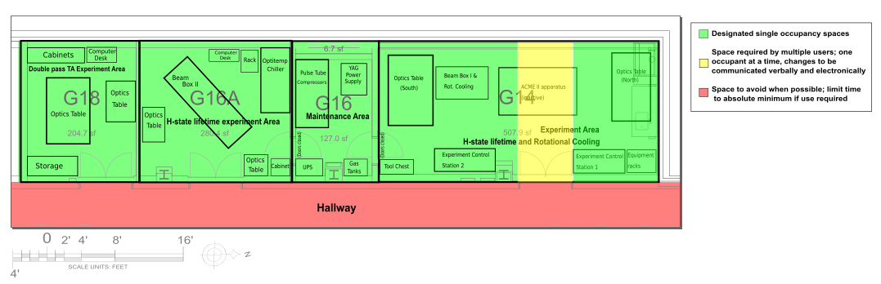
Fig. 2.a.1 LISE G14, G16, G16A, and G18, which comprise a suite of laboratory spaces used by the ACME experiment.

Work to be performed
The equipment on the North optics table (the TiSapph laser) and the North experimental control station will be used for the “H-state lifetime” project. The equipment on the South optics table and the “Beam Box I” apparatus will be used for the “Rotational cooling” project.

Procedures to minimize risk of transmission
See “General Laboratory Mitigation Procedures” described near the top of this appendix. There are two experimental control stations in the room (North and South) separated by 6 feet from each other. Each will be assigned to one of the two lab members authorized to work in the room, eliminating any shared surfaces. The room will be single occupancy. Desk spaces and other contact surfaces will be wiped down at the end of a shift. The door between G14 and G16 will be closed at all times during the YELLOW phase except for emergencies. Entrance and exit will be through the double doors connecting to the hallway utilizing the one-time use wax paper sheets detailed above. Entries will be planned so that no more than one person is in each of the two work spaces in the room (North and South) simultaneously and sufficient time is allocated for the exit of one person and entrance of another one. Other lab members may enter only with prior notice to all other ACME subgroup researchers and dwell times <1 m. In this case, hands-free entrance procedures shall be employed.

Personnel with access
Only three persons (Meisenhelder, Ang, and Chow) are authorized to work in LISE G14.

Schedule to minimize overlap of personnel
Any work that can be conducted off-campus (e.g., data analysis, software development, hardware design, etc.) will be. At most two people will be permitted in LISE G14 at any given time, with one person on the North side and one on the South side.

Preparation of room for resumption of work
Prior to work resumption signage will be posted on the room indicating the list of persons authorized to occupy the room and a prohibition on others from entering except by prior notice and consent from the primary person authorized to work in the room. One-time use wax paper sheets and trash receptacles will be placed on either side of the doors to both LISE G14 and the hallway.

2.b. LISE G16
Physical Overview
LISE G16 is a small “pump room” located in between G16A and G14. See Fig. 2.a.1. It contains 3 compressors, a UPS, and power supply for a YAG laser. The room is approximately 127 sq. ft. in area. There are two entrances to the room: one connecting to G14 and one to G16A. The room receives 36 fresh air changes per hour. The HVAC system in the room is HEPA filtered, however the HVAC filtered air supply is currently zero, which Siemens will fix.

Preparation of room for resumption of work
The door connecting to G14 will be closed and a sign posted on both sides to prohibit opening. The door connecting to G16A will be closed and a sign posted on both sides to prohibit opening with the exception of authorized personnel.

Work to be performed
There will be no regular experimental work performed in the room, with the exception of periodic (1-2 times a day) maintenance and check-ins for short duration <5m.

Procedures to minimize risk of transmission
See “General Laboratory Mitigation Procedures” described near the top of this appendix. Entrance and exit to the room will be limited to only one authorized perso d n. No other persons other than those listed in “Personnel with access” are authorized to enter the room except by prior notice to all other ACME lab personnel and consent from the person(s) listed in “Personnel with access”. Entries by non-regularly authorized personnel will be performed by using the wax paper sheets provided to ensure that it remains touch-free. Such entries will be planned so that no more than one person is in the room simultaneously (except for dwell times <1 m) and a wait time of 10 minutes is allocated for the exit of one person and entrance of another one.

Personnel with access
No regular experimental work takes place in LISE G16. Only one person (Daniel Ang) will work in 16A, only to perform periodic maintenance as detailed above.

2.c. LISE G16A
Physical Overview
LISE G16A houses several important components of the ACME project, including two optics tables with various lasers and optics and the “Beam Box II” apparatus currently being used for the “H-state lifetime” measurement. See Fig. 2.a.1. The room is approximately 280 sq. ft. The room has a HEPA filtered HVAC system that provides >5 fresh air changes per hour. The room receives 5.8 fresh air changes per hour, but does not have a HEPA filtered HVAC system. There are two entrances to the room: a double door connecting to the hallway and a single door connecting to G16.

Preparation of room for resumption of work
The door connecting to G16A will be closed. Signage will be posted on the door indicating the list of persons authorized to occupy the room and a prohibition on others from entering except by prior notice to all other ACME lab personnel and consent from the primary person authorized to work in the room. One-time use wax paper sheets and trash receptacles will be placed on either side of the doors to the hallway.

Work to be performed
The “H-state lifetime” project will be performed in this room.

Procedures to minimize risk of transmission
See “General Laboratory Mitigation Procedures” described near the top of this appendix. Entrance and exit to the room will be limited to only one authorized person (Daniel Ang). The person authorized to occupy this room will enter and exit through the door connecting to the hallway, except when performing periodic maintenance in G16, during which the door connecting to G16 will be used. The wait time before any other people can enter the room is 1 hour.

Personnel with access
Only one person (Daniel Ang) will work in LISE G16A.

2.d. LISE G18
Physical Overview
LISE G18 houses some secondary components of the ACME apparatus. It contains two optics tables and several storage cabinets. See Fig. 2.a.1. The room is approximately 205 sq. ft. There is one double door entrance to the room connected to the hallway. The room receives 2.5 fresh air changes per hour, and has a HEPA filtered AHU designed to give the room a negative flow rate of 100 CFM.

Preparation of room for resumption of work
Prior to work resumption signage will be posted on the room indicating the list of persons authorized to occupy the room and a prohibition on others from entering except by prior notice to all other ACME lab personnel and consent from the primary person authorized to work in the room. One-time use wax paper sheets and trash receptacles will be placed on either side of the doors to the hallway.

Work to be performed
This room will be used for the “Double pass tapered amplifier” project.

Procedures to minimize risk of transmission
See “General Laboratory Mitigation Procedures” described near the top of this appendix. Entrance and exit to the room will be limited to only one authorized person (Zhen Han). The person authorized to occupy this room will enter and exit through the door connecting to the hallway.

No other persons other than those listed in “Personnel with access” are authorized to enter the room except by prior notice to all other ACME lab personnel and consent from the person(s) listed in “Personnel with access”. Entries by non-regularly authorized personnel will be performed by using the wax paper sheets provided to ensure that it remains touch-free. Such entries will be planned so that no more than one person is in the room simultaneously (except for dwell times <1 m) and a wait time of 2.5 hours will be allocated for the exit of one person and entrance of another one.

Personnel with access
Only one person (Zhen Han) will work in LISE G18.

3. Jefferson First Floor
The first floor of Jefferson contains three additional laboratory spaces used solely by the ACME subgroup, Jefferson 160, 161, and 162.

Short description: the only change introduced for this part is to reflect the recent upgrade of fresh air flow rate in Jefferson 160, from nominally 190 CFM to now nominally 290 CFM. As Jefferson 160 has a 860 sq.ft size, this fresh air flow rate upgrade allows us to have now maximally 2 people to work there while still satisfying the 100 CFM/person requirement on fresh air flow rate, and the 200 sq.ft/person requirement on lab space. A minimual 9 feet distance will be maintained when 2 people work in the J160. With 2 people working in J160, it helps to mitigate the lab safety concern associated with the High Voltage testing planned in the lab space.

3.a. Jefferson 160
Physical Overview
Jefferson 160 is an experimental area (including also Jefferson 160e) which is sealed off from Jefferson 161 for airflow purposes using vinyl strips. A wall seals off the experimental area from Jefferson 160f, which is currently being used by the construction crew of the adjacent Mitrano labs. See Fig. 3.a.1. Jefferson 160. The total area of the workspace (designated in green) is about 860 sq. ft. There are several entrances to the room: a single door connecting to Jefferson 160f (always closed), a door leading to the hallway, a staircase to the door of the offices upstairs (Jefferson 263), and a ramped hallway leading to Jefferson 160 without a door, which will be sealed with a vinyl strip door to prevent air flow. Additional hardware has been brought in which brings about 290 CFM of fresh air.

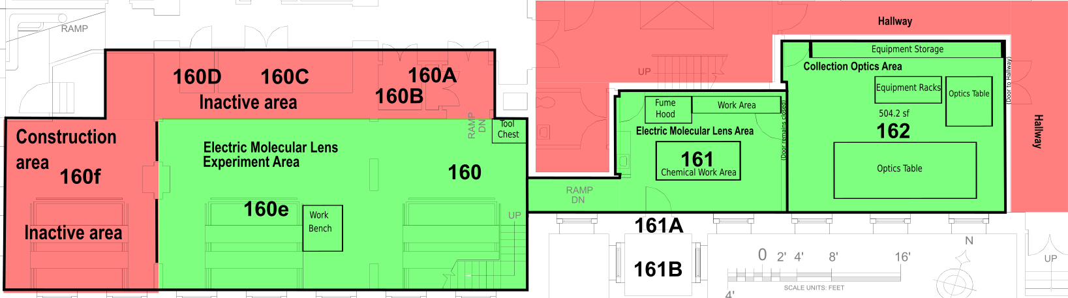Fig. 3.a.1 Jefferson 160, 161, 162 labs used by the ACME subgroup.

Preparation of room for resumption of work
Prior to work resumption signage will be posted on the door indicating the list of persons authorized to occupy the room and a prohibition on others from entering except by prior notice to all other ACME lab personnel and consent from the primary person authorized to work in the room. One-time use wax paper sheets and trash receptacles will be placed on either side of the doors to the hallway. A sign will be posted on outside of the doors to Jefferson 160f, 161, and to the hallway to prohibit opening with the exception of authorized personnel.

Work to be performed
This room will be used for the “Electric molecular lens” project.

Procedures to minimize risk of transmission
See “General Laboratory Mitigation Procedures” described near the top of this appendix. Entrance and exit to the room will be limited to only personnel with access. The persons authorized to occupy this room will enter and exit through the staircase leading to the offices upstairs. All other doors will be closed and not regularly used.

No other persons other than those listed in “Personnel with access” are authorized to enter the room except by prior notice from the person(s) listed in “Personnel with access”. Entries by non-regularly authorized personnel will be performed by using the wax paper sheets provided to ensure that it remains touch-free. Such entries will be planned so that no more than one person is in the room simultaneously (except for dwell times <1 m) and a wait time of 8 hours is allocated for the exit of one person and entrance of another one.

Personnel with access
Three persons (Xing Wu, James Chow, Zhen Han) will work in Jefferson 160. Only maximally two people at a time are allowed to work in the room.

3.b. Jefferson 161
Physical Overview
Jefferson 161 is the ACME prep lab area, which will be sealed off from Jefferson 160 for airflow purposes. See Fig. 3.a.1. Jefferson 161 contains a fume hood, chemical storage cabinet and chemical preparation area and is about 271 sq. ft. There are several entrances to the room: one single door connecting to Jefferson 162, one single door leading to the hallway, and a ramped hallway leading to Jefferson 160 without a door, which will be sealed with a vinyl strip door to prevent air flow.

Harvard physical plant has indicated that the room currently receive no fresh air changes; work will continue to attain full knowledge of the HVAC system in this space. This room has recirculating fan coils without HEPA filters and a fume hood which causes air flow. The coil for Jefferson 161 is not currently operating, but the exhaust for the fume hood circulates the air >8 times per hour. Additional hardware has been brought in which brings about 190 CFM of fresh air.

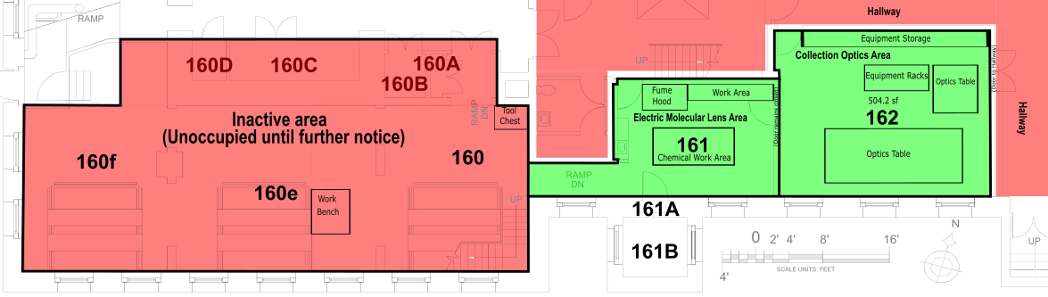
Fig. 3.a.1 Jefferson 161, 162 labs used by the ACME subgroup.

Preparation of room for resumption of work
Prior to work resumption signage will be posted on the door indicating the list of persons authorized to occupy the room and a prohibition on others from entering except by prior notice to all other ACME lab personnel and consent from the primary person authorized to work in the room. One-time use wax paper sheets and trash receptacles will be placed on either side of the doors to the hallway. The door from Jefferson 161 to the hallway and a sign posted on outside of the door to prohibit opening with the exception of authorized personnel.

Work to be performed
This room will be used for the “Electric molecular lens” project.

Procedures to minimize risk of transmission
See “General Laboratory Mitigation Procedures” described near the top of this appendix. Entrance and exit to the room will be limited to only those listed in “Personnel with access”. The person authorized to occupy this room will enter and exit through the single door connecting Jefferson 161 to the hallway.

No other persons other than those listed in “Personnel with access” are authorized to enter the room except by prior notice from the person(s) listed in “Personnel with access”. Entries by non-regularly authorized personnel will be performed by using the wax paper sheets provided to ensure that it remains touch-free. Such entries will be planned so that no more than one person is in the room simultaneously (except for dwell times <1 m) and a wait time of 8 hours is allocated for the exit of one person and entrance of another one.

Personnel with access
Three persons (Xing Wu, James Chow, Zhen Han) will work in Jefferson 161. Only one person at a time is allowed to work in the room.

3.c. Jefferson 162
Physical Overview
Jefferson 162 contains several important lasers, optics, computers, and several work tables. There are three entrances to the room: two connecting to the hallway (one double-door, one single door), and one leading to Jefferson 161. The room is approximately 504 sq. ft. Harvard physical plant has indicated that this room currently receives no fresh air changes; work will continue to attain full knowledge of the HVAC system in this space. This will be done during the preparation stage of returning to lab. This room has recirculating fan coils, which are not HEPA filtered, that circulate the air >12 times per hour. Additional hardware has been brought in which brings about 190 CFM of fresh air.

Preparation of room for resumption of work
Prior to work resumption signage will be posted on the door indicating the list of persons authorized to occupy the room and a prohibition on others from entering except by prior notice to all other ACME lab personnel and consent from the primary person authorized to work in the room. One-time use wax paper sheets and trash receptacles will be placed on either side of the doors to the hallway. The double door to the hallway will be closed.

Work to be performed
This room will be used for the “Collection optics” project.

Procedures to minimize risk of transmission
See “General Laboratory Mitigation Procedures” described near the top of this appendix. Entrance and exit to the room will be limited to only one authorized person (Daniel Ang). The person authorized to occupy this room will enter and exit through the single door connecting Jefferson 162 to the hallway.

No other persons other than those listed in “Personnel with access” are authorized to enter the room except by prior notice from the person(s) listed in “Personnel with access”. Entries by non-regularly authorized personnel will be performed by using the wax paper sheets provided to ensure that it remains touch-free. Such entries will be planned so that no more than one person is in the room simultaneously (except for dwell times <1 m) and a wait time of 8 hours is allocated for the exit of one person and entrance of another one.

Personnel with access
Only one person (Daniel Ang) is authorized to work in Jefferson 162.

4. 38 Oxford St.
Physical Overview
The group’s 38 Oxford Street area contains long-term storage (crates, large laboratory equipment, etc.), metal/plastic stock used for experiment construction. Construction is currently underway to install a self contained enclosed structure for performing experiments. Until that construction is complete, it is expected that only retrieval of stored items will take place.
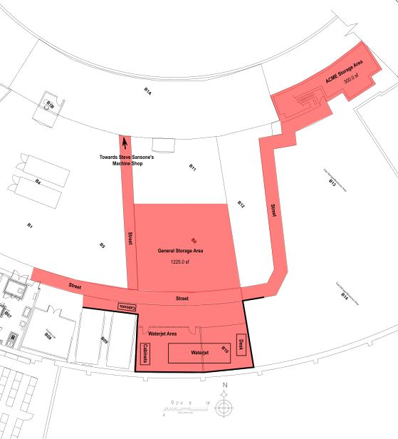
Figure 4.1 38 Oxford Street area

Preparation of room for resumption of work
38 Oxford will be added to a ‘live’ scheduling document in order to ensure single occupancy of the space. Gloves will be placed in the space to allow Level 1B gloving procedures to be implemented.

Work to be performed
This space can be used to retrieve necessary laboratory equipment and/or materials stock.

Procedures to minimize risk of transmission
The space will be single occupancy and require signup via a shared ‘live’ Google doc. Level 1B procedures will be followed at all times.

Personnel with access
All group members will have access to 38 Oxford Street.

5. Auxiliary preparation spaces
Auxiliary spaces and their relevant properties are listed in Table 5.1. General guidelines applying to all such spaces are: single occupancy, use of a shared “live” document to schedule usage of space, and a required wait time between users. Hands-free timers will be placed outside these shared spaces to ensure adequate wait time between users.

Room | Primary use | Air flow [CFM]  (Fresh airlow [CFM]) | HEPA? | Capacity | Authorized Personnel
Lyman 27 | Electronics room | 280  (280) | No | 1 | All
Lyman 23C | Gas closet | Hallway air, door propped open | No | 1 | All
Lyman 24A | CaOH foyer | >100 CFM from 24D | Yes | 1 | Louis Baum, Christian Hallas, Debayan Mitra, Shivam Raval, Nathaniel Vials
Lyman 24B | Optics storage | >100 CFM from 24D | Yes | 1 | Louis Baum, Christian Hallas, Debayan Mitra, Shivam Raval, Nathaniel Vilas, Loic Anderegg, Yicheng Bao, Sean Burchesky, Scarlett Yu
Lyman 24F | Mechanical room | >500 CFM from 24E | Yes | 1 | Louis Baum, Christian Hallas, Debayan Mitra, Shivam Raval, Nathaniel Vials, Loic Anderegg, Yicheng Bao, Sean Burchesky, Scarlett Yu
Lyman 31 | Chemical room / fume hood | >560 CFM from hallway | No | 1 | All
Tab. 5.1 Group auxiliary spaces and relevant airflow properties.

5.a. Lyman 23C
Physical overview
Lyman 23C is used for storage of gas cylinders and miscellaneous lab supplies (sheet stock, tubing, etc.). See Fig. 5.a.1. Door to the hallway is propped open.
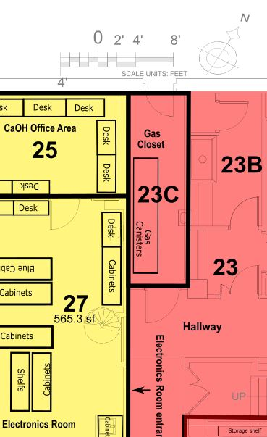
Figure 5.a.1 Lyman 23C and surrounding rooms.

Preparation of room for resumption of work
Touch free entrance and exit will be ensured by placing one-time use wax paper sheets and trash receptacles on either side of the door.

Personnel with access
All group members have access to Lyman 23C (due to the potentially time-critical need for gas cylinders stored therein).

Work to be performed
Access to Lyman 23C will be used solely to store and retrieve gas cylinders required for essential laboratory work. Exchanging a gas cylinder typically requires ~5 minutes researcher dwell time.

Schedule to minimize overlap of personnel
A hands-free timer will be installed near the door. Upon exiting the room, the user will activate the timer and the next user may not enter until three hours have elapsed. To minimize use of the room in general, it is recommended that a user retrieve all required gas cylinders in one set of visits.

Procedures to minimize risk of transmission
The door to the gas closet will be propped open to allow hands-free entry and to aid with air circulation. Level 1B procedures of “Covid Transmission Risk Mitigation Procedures” will be implemented. In particular, new gloves will be donned before touching any gas cylinder and cylinder status label. If signage is to be affixed to a cylinder, the paper and pen used to write the sign will be used at the person’s assigned desk (using already distributed office supplies). The gas cylinder hand truck will be cleaned and wiped down before and after each usage.

5.b. Lyman 24A
Physical overview
Lyman 24A is the entrance foyer to the Lyman 24BCD laboratory spaces. It contains a sink as well as storage shelving for some laboratory PPE and cleaning supplies. It may be accessed via separate doors to the hallway, Lyman 24B, Lyman 24C, and Lyman 24D. See Fig. 5.b.1. The space receives >100 CFM HEPA-filtered air flow from 24D.

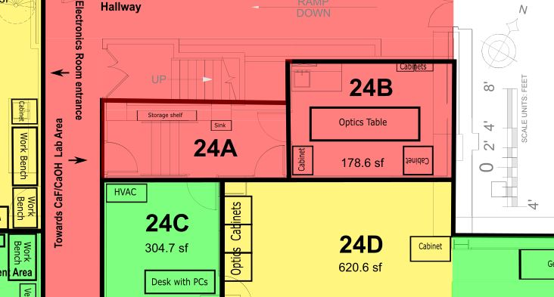
Figure 5.b.1 Lyman 24A and surrounding rooms.

Preparation of room for resumption of work
Touch free entrance and exit will be ensured by placing one-time use wax paper sheets and trash receptacles on either side of the door into the hallway. Touch free access through other doorways is separately described in procedures for Lyman 24BCD spaces.

Personnel with access
Only those group members with access to Lyman 24C are regularly allowed in this space. Personnel authorized for use of Lyman 24DE may also briefly pass through Lyman 24A to access storage in Lyman 24B. Entry for periods of <1 minute by other members of the group to retrieve stored PPE and cleaning equipment is allowable, but such activities should be mitigated whenever possible by storage of these supplies elsewhere.

Work to be performed
Lyman 24A may only be used for access to Lyman 24BC, retrieval of PPE and cleaning supplies, and/or hand washing.

Schedule to minimize overlap of personnel
This space should never be occupied for periods of more than 1 minute, and only ever by one lab member at a time.

Procedures to minimize risk of transmission
Level 1B procedures of “Covid Transmission Risk Mitigation Procedures” will be implemented. Hands-free entry will be used for access via all doorways, as described above. Any contact surfaces will be wiped down after use.

5.c. Lyman 24B
Physical overview
Lyman 24B is used for storage of optics and miscellaneous lab supplies; it measures 179 sq. ft (Fig. 5.c.1). This space is not currently serviced by an HVAC unit (construction of new HVAC is pending) and features >100 CFM HEPA-filtered airflow from Lyman 24D. There is a single entrance/exit which opens into Lyman 24A.
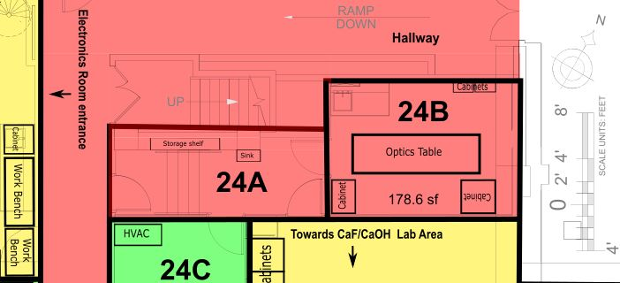
Figure 5.c.1 Lyman 24B and surrounding rooms.

Preparation of room for resumption of work
The door to Lyman 24B will be left propped open (as usual) to allow hands-free entry. HVAC commissioning should be completed before return to laboratory work.

Personnel with access
Only members of the group with access to Lyman 24CDE will be permitted in Lyman 24B, for time periods of <1 minute exclusively to retrieve stored optics and lab supplies.

Work to be performed
Access to Lyman 24B will be for the sole purpose of retrieving stored optics or lab supplies.

Schedule to minimize overlap of personnel
All efforts should be made to retrieve any optics required for daily work in a single trip, and trips should be limited to < 1 minute.

Procedures to minimize risk of transmission
Level 1B procedures of “Covid Transmission Risk Mitigation Procedures” will be implemented. New gloves will be donned before entering. Cabinets used will be wiped down after supplies have been retrieved. Dwell times will be restricted to < 1 minute in order to minimize contamination and exposure.

5.d. Lyman 24F
Physical overview
Lyman 24A (colloquially known as the “mechanical room”) contains cryogenic pulse tube compressors and chilled water circulators. See Fig. 5.d.1. It may be accessed through doors to Lyman 34 (the “SEAS machine shop”). The room receives >500 CFM from 24E.

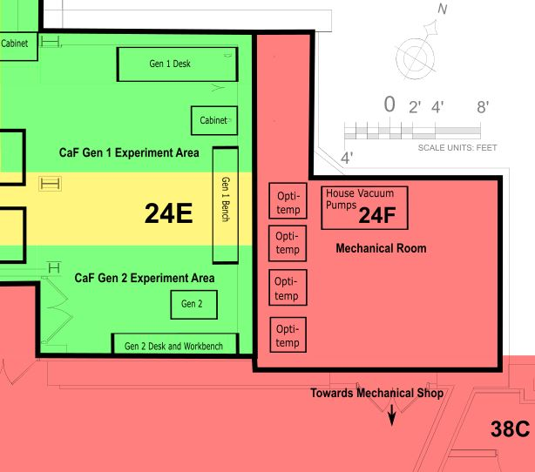
Fig. 5.d.1 Lyman 24F, a mechanical room containing water chillers and pulse tube compressors for the CaOH and CaF experiments.
Preparation of room for resumption of work
Touch free entrance and exit will be ensured by placing trash receptacles for one-time use wax paper sheets near the door between Lyman 24F and Lyman 34, as well as near both entry doors to Lyman 34 from the hallway.

Personnel with access
Doyle group members with access to Lyman 24CDE are allowed in this space.

Work to be performed
Lyman 24F is to be accessed solely for power cycling and maintenance of pulse tube compressors and water chillers.

Schedule to minimize overlap of personnel
This space should never be occupied by more than one lab member at a time or for periods significantly longer than 1 minute. If possible, no more than one lab member per day should enter this space.

Procedures to minimize risk of transmission
Level 1B procedures of “Covid Transmission Risk Mitigation Procedures” will be implemented. Hands-free entry will be used for access via all doorways using wax paper sheets, touch-free handles, or other body parts, as described in the Level 1B procedures. Any contact surfaces will be wiped down after use; alternatively, surface transmission will be mitigated using the “double-glove” method described in the Level 1B procedures.

5.e. Lyman 27
Physical overview
Lyman 27 houses the “electronics room” and “Lista cabinet” storage area. See Fig. 5.e.1 for a schematic of the room, including regions indicating where researchers may spend time. The room is approximately 35 ft x 15 x 11 ft and features 186 CFM total fresh airflow, equivalent to 1.9 fresh air changes per hour. There is no HEPA filter servicing the air in this room.
Lyman 27 houses an electronics bench table, five sets of cabinets for shared equipment, vacuum ovens, sink, and sonicators. The room has two entrance points: (1) a door (with a physical lock) opening to the basement-level hallway, and (2) an open staircase leading up to the Lyman 123 offices.

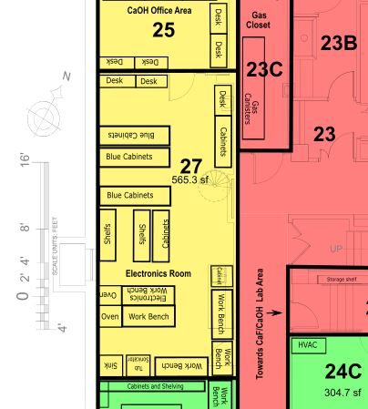
Fig. 5.e.1 Lyman 27, housing a sonication area, vacuum ovens, and electronics stations and general storage.

Preparation of room for resumption of work
Touch free entrance and exit from Lyman 27 will be ensured by placing one-time use wax paper sheets and trash receptacles on either side of the door. In addition, hands-free door handles may be installed.

Personnel with access
As a necessary preparatory space, all members of the group will be allowed to work in Lyman 27. However, as outlined below, at most one person will be permitted in the space at any given time and a hands free timer will be installed to ensure sufficient wait time. Passage through Lyman 27 to move from offices to laboratories is strongly discouraged; public corridors should be used whenever possible.

Work to be performed
Lyman 27 will be used only for tasks necessary to maintain working experiments. This includes soldering and electronics work; cleaning, sonication, and “baking” of vacuum components; and other auxiliary tasks. In addition, experimental supplies may periodically require retrieval from storage cabinets (“Lista cabinets”). Such retrieval is allowed without being treated as room “occupancy” so long as it is kept below 1 minute in duration and is avoided whenever possible.

Schedule to minimize overlap of personnel
At most one researcher will be permitted in Lyman 27 at any given time. A wait time of > 3 hours, corresponding to 6 fresh air changes, is required between occupancy. A hands-free timer will be installed near the door. Upon leaving the room, a user will activate the timer and nobody else may enter until it has run down. Use of this room should be minimized whenever possible, with use of designated experimental spaces or off-campus work preferred. Quick passage through the space in order to access the Lyman 27A or Lyman 123 offices is discouraged, though allowed if necessary. Temporary HEPA filter may be installed in the future to reduce wait times.

Procedures to minimize risk of transmission
Level 1B procedures of “Covid Transmission Risk Mitigation Procedures” will be implemented. In particular, desk spaces and equipment (e.g. soldering irons) used will be wiped down at the end of each day. In addition, gloves will be worn and changed at regular intervals using the ‘double glove’ method outlined in the Level 1B procedures. Room entrance and exit will use a hands free method as described above.
5.f. Lyman 31
Physical overview
Lyman 31 is the chemical/fume hood room. The back portion, Lyman 31A, is a mechanical room belonging to the YbOH experiment containing water chillers and pulse tube compressors. See Fig. 5.f.1. This room receives >18 air changes per hour from the hallway.

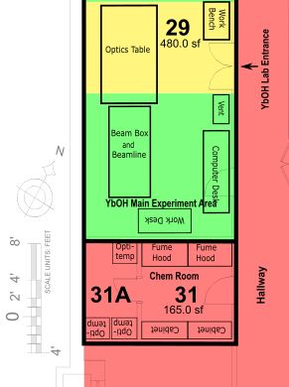
Fig. 5.f.1 Chemical/ fume hood room and YbOH mechanical area.

Preparation of room for resumption of work
Touch free entrance and exit will be ensured by placing one-time use wax paper sheets and trash receptacles on either side of the door.

Personnel with access
All group members will have access to Lyman 31 because it contains storage space for essential chemicals and a fume hood for working. Only YbOH subgroup members will have access to the back portion of the room which contains mechanical components connected to this experiment. Time spent in this room will be minimal.

Work to be performed
Generally, group members will access Lyman 31 for the sole purpose of using the fume hood for short tasks < 5 minutes, or for retrieving/storing chemicals. YbOH subgroup members may further access the mechanical room to maintain pulse tube compressors and water chillers.

Schedule to minimize overlap of personnel
A hands-free timer will be installed near the door. Upon exiting the room, the user will activate the timer and the next user may not enter until 30 minutes have elapsed. Time spent in the room will be limited to 5 minutes or less.

Procedures to minimize risk of transmission
Level 1B procedures of “Covid Transmission Risk Mitigation Procedures” will be implemented. New gloves will be donned before entering. Tabletops and the fume hood sash will be wiped down following work near these surfaces.

6. Office spaces
Group office spaces and their relevant properties are listed in Table 6.1. As indicated throughout this document, each room is single occupancy.

A note on eating meals:
In order to minimize the risk of infection due to meals, the following procedures will be established:
- Each person has a designated area to eat, i.e. a desk or designated table space. Each designated space will be assigned to a single person who is the only permitted user.
  - Individuals with assigned desks will eat in these spaces. Individuals occupying the conference room will have an assigned table seat for their use.
- In cases where the assigned spaces do not ensure full disconnect between people eating, a staggered timing will be adopted to eliminate overlap of personnel. Wait times will be determined by local airflow conditions.
- The timing of meals will be scheduled using a “live” Google doc that individuals will edit for each day.
  - This shared Google doc will also help eliminate proximity of persons in hallways and corridors leading to assigned lunch areas; at least 5 minutes between planned occupation of a corridor will be required.

Room | Primary former use | Air flow [CFM]  (Fresh airlow [CFM]) | HEPA? | Capacity | Authorized Personnel
Lyman 123 | Foyer | 67  (48) | No | 1 | All with access to Lyman 123ABCD
Lyman 123A | Conference room | 629  (138) | No | 1 | Loic Anderegg, Sean Burchesky
Lyman 123B | Office | 149  (26) | No | 1 | Ben Augenbraun, Zack Lasner
Lyman 123C | Office | 438  (50) | No | 1 | Alex Frenett, Hiromitsu Sawaoka
Lyman 123D | Office | 170  (33) | No | 1 | Yicheng Bao, Scarlett Yu
Lyman 25 | Office | 592  (120) | No | 1 | Louis Baum, Christian Hallas, Debayan Mitra, Shivam Raval, Nathaniel Vilas
Jefferson 263 | Office | 459  (50) | No | 1 | Daniel Ang, Cole Meisenhelder, Xing Wu, James Chow, Zhen Han
Tab. 6.1 Doyle group office spaces and relevant airflow properties. These fresh air flow numbers are determined by the suite total provided by physical plant operatives and the distribution based on square footage.

6.a. Lyman 123 and 123ABCD
Physical overview
Lyman 123 houses the primary group office space. See Fig. 6.a.1 for a schematic of the room, including regions indicating where researchers may spend time. This room consists of four sub-rooms and a foyer. The sub-rooms are separated by glass walls and glass doors. Each Lyman 123BCD sub-room features its own air circulation (Table 6.1). The full Lyman 123 suite receives 294 CFM fresh air input, corresponding to >2 fresh air exchanges per hour. There are no HEPA filters installed in the HVAC system for this space. The entrance to Lyman 123 can be activated by a touch-free ID card key. On the other side of this entrance, a touch-free exit “handle” has already been installed. Each room will be single occupancy only, and within each room there will be a single desk assigned to each person with access.
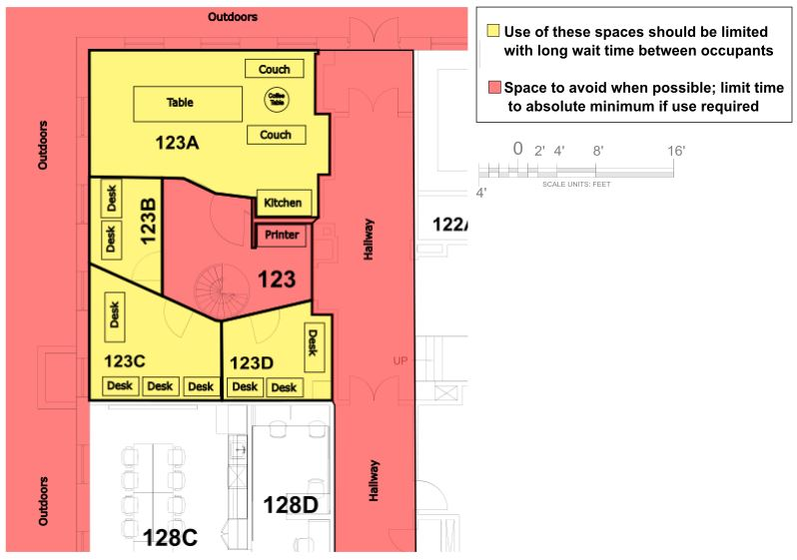
Fig. 6.a.1 Lyman 123 including offices, foyer, and conference room. These areas are colored yellow even though they are single occupancy so as to denote that in this initial startup phase they are not intended to be used for long periods of time.

Preparation of room for resumption of work
Touch free entrance and exit from each subunit of Lyman 123 will be ensured by placing one-time use wax paper sheets and trash receptacles on either side of the glass doors of each sub-room, or by installing touch-free entrance handles on these doors. Prior division of office supplies would be coordinated to avoid touching shared drawers. Desks will be assigned one per person with no shared desks. They will be clearly labeled. Assignments will ensure that no two people with access on the same day are located in the same office.

Personnel with access
Individual sub-rooms within Lyman 123 will be divided by experimental subgroup (see Table 3.1) to minimize contact between individuals. Members of the CaF subgroup will have access to Lyman 123A and Lyman 123D. Members of the YbOH subgroup will have access to Lyman 123B and Lyman 123C. Other lab members are not permitted to enter designated subgroup office spaces except with prior notice and dwell times < 1 minute. The foyer area may be occupied by all group members only for short times of <1 minute.

Work to be performed
Lyman 123 is to be treated as limited-use office space, primarily for storage of personal items and eating of meals that cannot be taken off the premises. It is not to be used for office work which can be completed at home (e.g., data analysis, software development, hardware design, etc.). Other, shorter office tasks should be done in designated laboratory spaces, and not Lyman 123, whenever possible.

Schedule to minimize overlap of personnel
The rooms are single occupancy. A wait time of at least 3 hours is to be followed between occupancies of each sub-room, in order to allow >6 fresh air exchanges. A live schedule will be used. Hands-free timers will be used for each room to ensure sufficient wait time between occupants.

Procedures to minimize risk of transmission
See “General Laboratory Mitigation Procedures” described near the top of this appendix. Desk spaces will be wiped down periodically. In addition, gloves will be worn and changed at regular intervals using the ‘double glove’ method outlined in the Level 1B procedures. Office entrance and exit will use a hands free method as described above and in the Level 1B procedures. Only one person at a time is allowed on the spiral staircase that leads down to Lyman 27. Sharing of common supplies (office supplies, kitchen supplies) is forbidden, and this must be communicated clearly by labels. Use of the refrigerator and espresso machine is forbidden.

6.b. Lyman 25
Physical Overview
Lyman 25 houses office spaces used by group members. See Fig. 5.e.1. The room contains six desks, although not all will be used under these guidelines. This room is connected to Lyman 27 via a single door. The HVAC system for this room is not HEPA filtered, and the room receives 120 CFM of fresh air, corresponding to >4 fresh air changes per hour. This room, like the other offices, will be single occupancy.

Preparation of room for resumption of work
Touch free entrance and exit will be ensured by placing one-time use wax paper sheets and trash receptacles on either side of the door. Desks will be assigned one per person and clearly labeled as such. Desk assignment will ensure that adjacent desks are not assigned to workers with access on the same day. Prior division of office supplies would be coordinated to avoid touching shared drawers.

Personnel with access
Members of the “CaOH experiment” (Louis Baum, Christian Hallas, Debayan Mitra, Shivam Raval, and Nathaniel Vilas) will be allowed access. Other lab members are not permitted to enter designated subgroup office spaces except with prior notice and dwell times < 1 minute.

Work to be performed
Lyman 25 is to be treated as limited-use office space, primarily for storage of personal items and eating of meals that cannot be taken off the premises. Only single occupancy is allowed for these purposes. It is not to be used for office work which can be completed at home (e.g., data analysis, software development, hardware design, etc.). Other, shorter office tasks should be done in designated laboratory spaces whenever possible.

Schedule to minimize overlap
The room is single occupancy, with one member of the CaOH subgroup in the room at any given time. A wait time of at least 90 minutes is to be followed between subsequent occupations of the space, in order to allow 6 complete fresh air exchanges. A live schedule document will be used. A hands-free timer will be placed at the entryway to ensure sufficient wait time between occupants.

Procedures to minimize risk of transmission
See “General Laboratory Mitigation Procedures” described near the top of this appendix. Desk spaces will be wiped down periodically. In addition, gloves will be worn and changed at regular intervals using the ‘double glove’ method outlined in the Level 1B procedures. Office entrance and exit will use a hands free method as described above and in the Level 1B procedures.

6.c. Jefferson 263
Physical Overview
Jefferson 263 houses office spaces used by members of the ACME experiment. The space is accessed by passing through the “G1 area.” The space is continuously connected to Jefferson 265, used for storage of ACME equipment. There are also doors leading to a shared computer alcove (261A), computer server room (261B), and small kitchen (261C). In the main office room (263) there are seven desks.

Harvard physical plant has indicated that these rooms currently receive no fresh air changes; work will continue to attain full knowledge of the HVAC system in this space. If it is definitively determined that there is currently no fresh air currently being brought into this space, additional hardware will be added to do so, providing a minimum of 50 CFM of fresh air. This room has a recirculating fan coil which is not HEPA filtered, that circulates the air 4 times per hour.

Preparation of room for resumption of work
Touch free entrance and exit will be ensured by placing one-time use wax paper sheets and trash receptacles on either side of the doors to both the “G1 area” and Jefferson 263. Desks will be assigned one per person and clearly labeled. Desk assignment will ensure that adjacent desks are not assigned to workers with access on the same day. Prior division of office supplies would be coordinated to avoid touching shared drawers.

Personnel with access
Members of the “ACME experiment” (Daniel Ang, Cole Meisenhelder, Xing Wu, James Chow, Zhen Han) will be allowed access. Other lab members are not permitted to enter designated subgroup office spaces except with prior notice and dwell times < 1 minute.

Work to be performed
Jefferson 263 is to be treated as limited-use office space, primarily for storage of personal items and eating of meals that cannot be taken off the premises. Only single occupancy is allowed for these purposes. It is not to be used for office work which can be completed at home (e.g., data analysis, software development, hardware design, etc.). Other, shorter office tasks should be done in designated laboratory spaces whenever possible.

Schedule to minimize overlap
The room is single occupancy. One researcher will be permitted in Jefferson 263 at any given time. A wait time of at least 8 hours (tbd) is to be followed between subsequent occupations of the space. A live schedule document will be used. A hands-free timer will be placed at the entryway to ensure sufficient wait time between occupants.

Procedures to minimize risk of transmission
See “General Laboratory Mitigation Procedures” described near the top of this appendix. Used desk spaces will be wiped down at the end of each day. In addition, gloves will be worn and changed at regular intervals using the ‘double glove’ method outlined in the Level 1B procedures. Office entrance and exit will use a hands free method as described above and in the Level 1B procedures.

